Family Registration:-
Registration :-Fill All data According to given Information
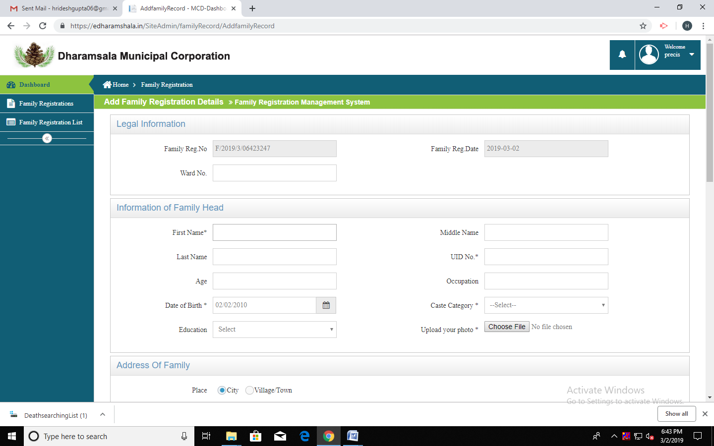
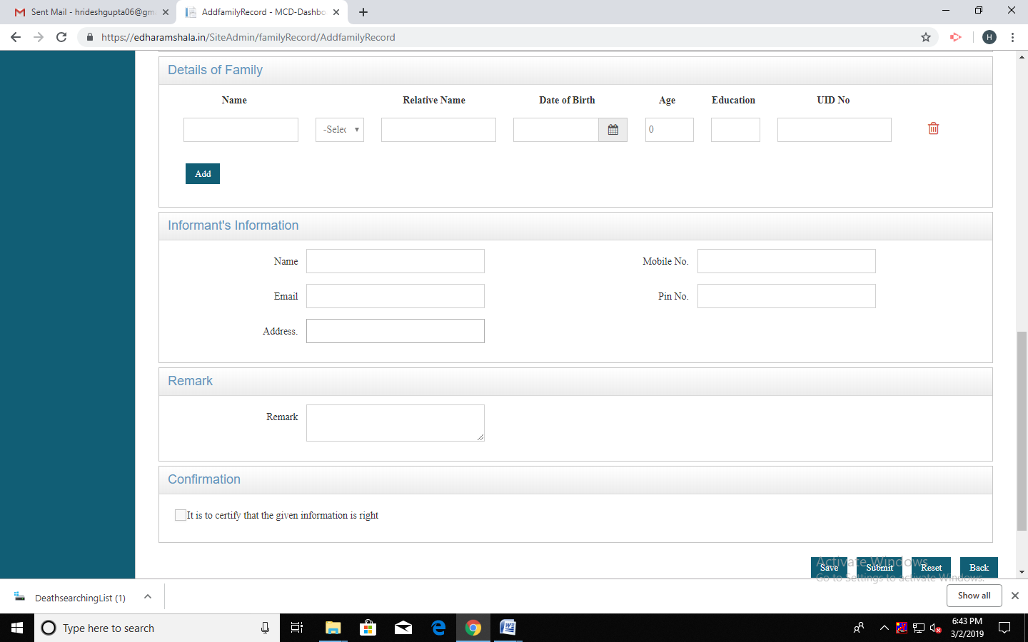
Family Registration
- Application
- Ration Card
:- Payment
:- Screenshot of Receipt
:- Approved BY familyofficer1 And familyregistar

